# Scenario 1

Scenario Description: This scenario tests the insertion procedure under ideal conditions, using table column values that are appropriate and should not cause error.

Scenario Screen Captures of Output:



# Scenario 2

Scenario Description: This scenario tests error messages and logging for various uses of the insertion procedure, using suboptimal table column values that are not appropriate, and likely to cause errors.

Scenario Screen Capture of Output:

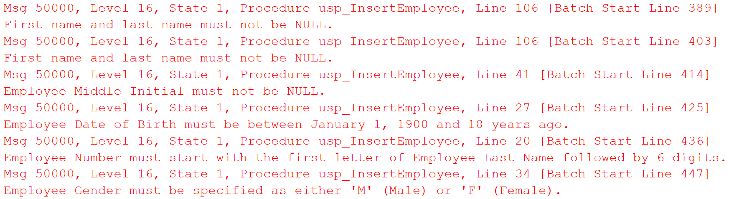

# Scenario N

Scenario Description: This scenario tests error messages and logging for various uses of the update procedure, using suboptimal table column values that are not appropriate, and likely to cause errors.

Scenario Screen Capture of Output:

